MyFedora Action Plan

Summary

- What is Done
  - API's
    - Application API
    - Resource View/Tool API
    - JavaScript module API
    - Async JavaScript Extension API
    - Remote Resource Querying patterns (aka how to get info from koji, bodhi, pkgdb, etc.)
    - Second generation of the CSS (along with patterns for using CSS)
    - URL layout
  - TurboGears 2 migration
  - Main Page basic layout and navigation
  - People and Packages resource view shells
  - Builds tool for People and Packages
    - failed build error log extension (show only the log which matters)
    - release extension (basic right now)
    - download extension in hover menu (guesses users arch and only display files needed for testing)
  - Info page for Packages
  - Search
    - on Packages
People search written but requires fas authentication
- What more will be done for F10 (pending design review)
  - Info Tool for People
    - including a basic profile view for logged in user
  - Index page for People
    - Search integration
    - Navigation integration
    - Basic user profile information
    - Basic information about latest user related events
      - users requesting permissions
      - users requesting sponsorship, etc.
  - Update (bodhi centric view) tool for people and packages
  - Permissions (pkgdb) tool for people and packages
    - people permissions should also have a fas view (eg groups) but that may need to wait until Fedora 11 if time does not permit
  - Build tool needs Bodhi push mechanism in MF's TG1 implementation to be ported to extensions and polished
  - Main page apps (enough to make it usable)
    - Navigation is on the left and done
    - middle needs one or two main focus apps
    - right needs a couple of informational apps
  - FAS Auth Middleware
  - CSS and design cleanups to make it look polished
  - Breadcrumb navigation

- Fedora 11 Focus
  - Workflow
    - Become a Fedora developer workflow
    - Add a package to Fedora workflow
  - Search cleanups and plotting the future of Fedora search
  - Flesh out tools and resource views
  - More cowbell (applications that is)
    - User configuration of cowbells

An Example of How Things Work Now

Packaging

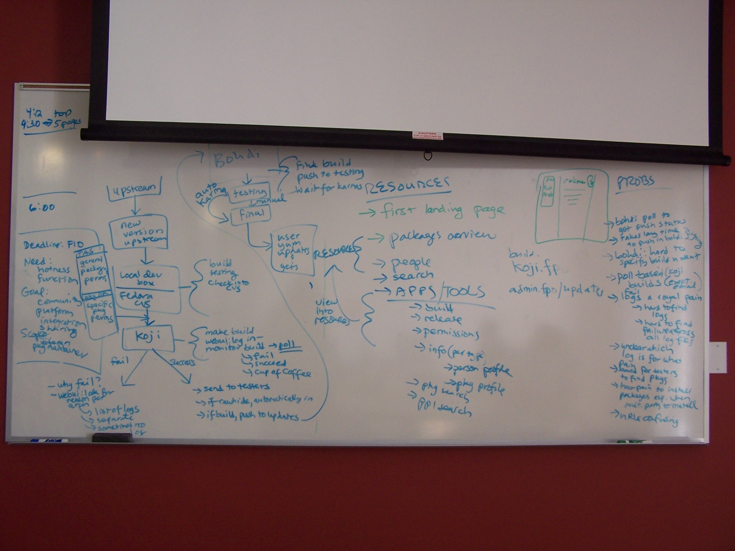
- User is somehow updated (polls/is notified) about a new version of an upstream package
- user checks out CVS, goes to the upstream website and downloads package, checks in changes and builds locally then in Koji
- User polls either the Koji web site at http://koji.fedoraproject.org/koji, his terminal where the build is happening or his mailbox to see when build has finished
    - If FAILED
      - goto the url for the build to start looking for the error: 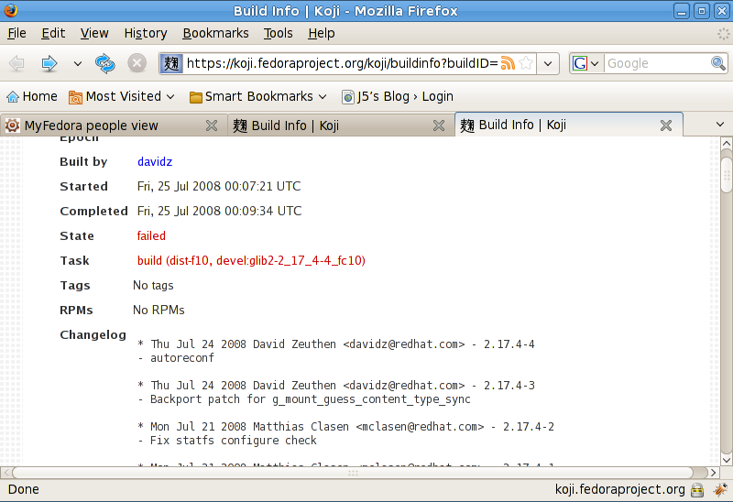
      - click on the task above which brings you to this screen: 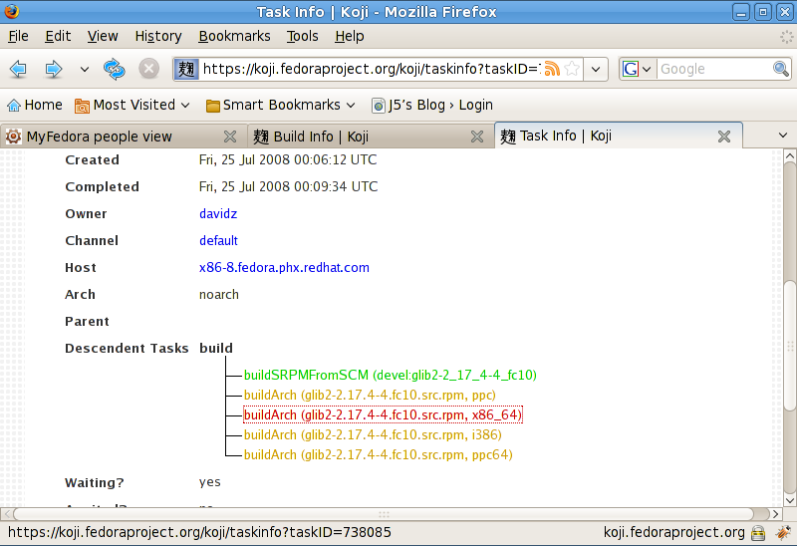
      - Click on the build task to get to this screen: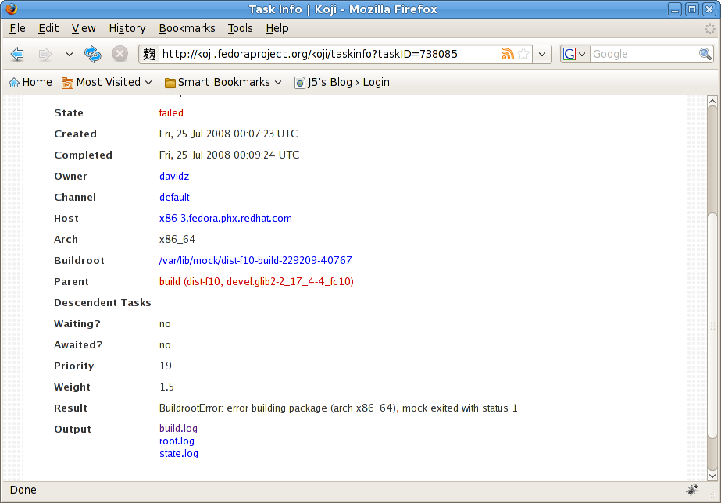
      - Click on the log in the output section you think has the error in it: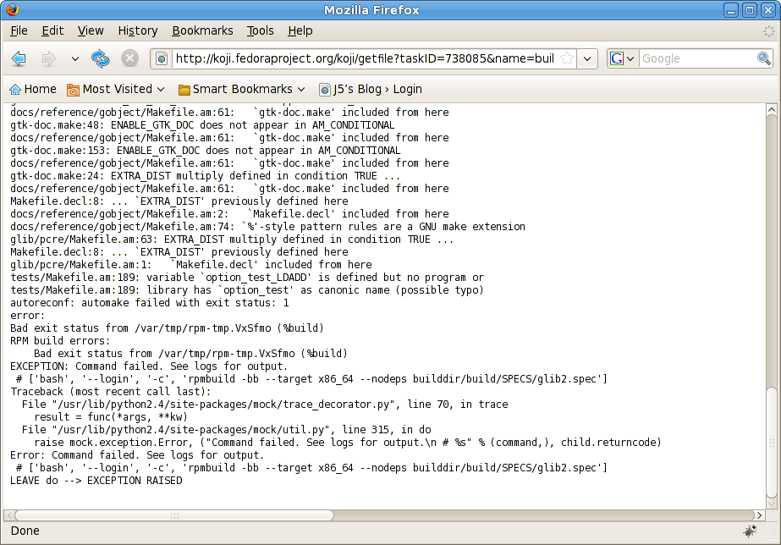
      - Go back and fix the package and start the process from the build stage again
    - If succeeded and this is a release build go to Bodhi at http://admin.fedoraproject.org/updates : 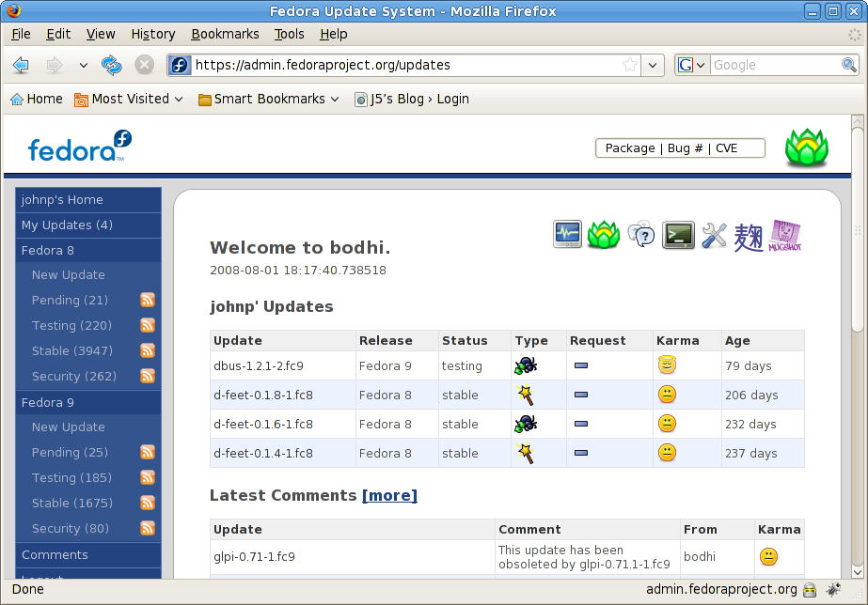
    - Click on New Update for the release you wish to update to get to this screen: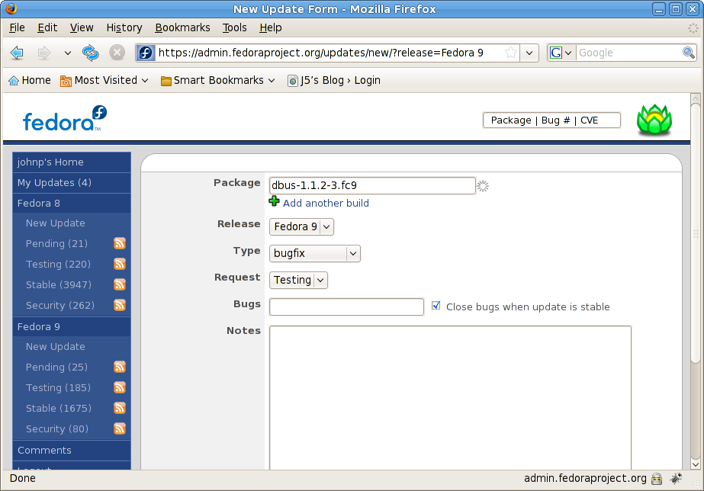
    - Type in the name and version which will try to autocomplete for you
    - After a while an admin will sign and push your package to the requested release collection (testing or final)

An Example of How it Should Work for F10 (and does in MyFedora)

- User goes through a similar build process as above until after step 2 (this will be optimized in later revisions)
- User goes to myfedora packages resource view for the package they just built – http://community.fedoraproject.org/packages/name/dbus or to the build tool in their peoples resource view - http://community.fedoraproject.org/people/name/davidz (urls do not exist yet):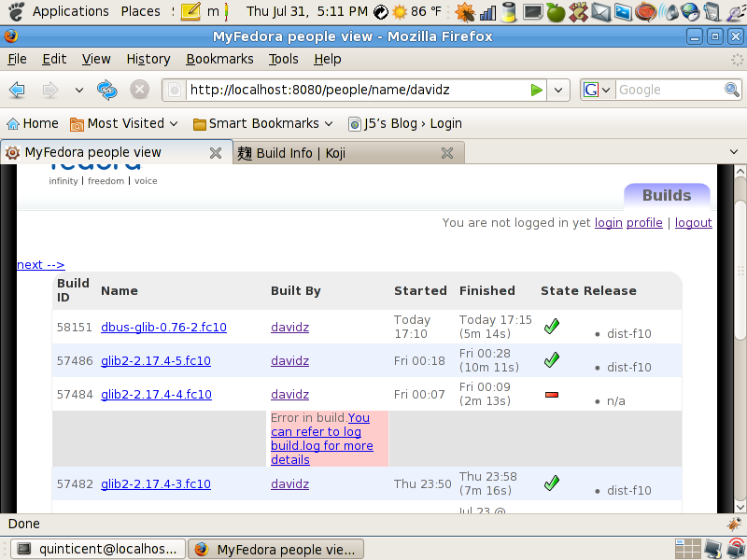
  - If the build failed
    - An error message will be generated under the build (ignore the layout error) with a link to the log where the error occurred if the log is still available :
    - User goes back to the build stage and starts over again
  - If succeeded
    - the user can mouse hover over the build name to get a drop down listing the a link for the details of the build and a list of packages for the arch the user is currently on to be used to test the build on their machine if they wish: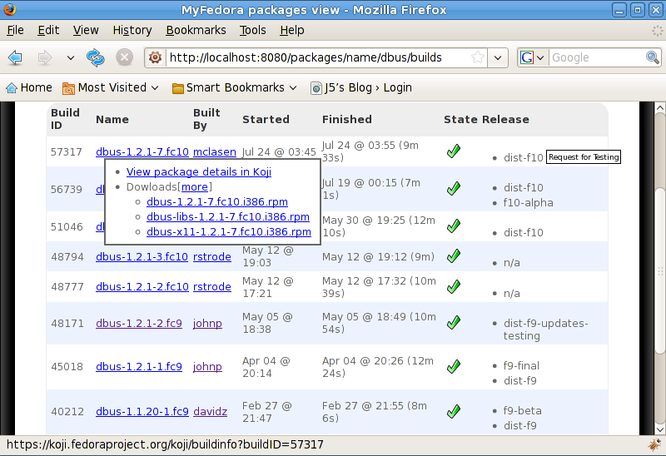
    - As mocked up above, if the package can be released by the logged in user a Request button will show up next to the release. In the case above a Request for Testing button pops up (one for final should also be there). Clicking on that would bring up an already filled in form with some extra field such as comments that the user can fill out and then confirm the request

Other screenshots and White Board pictures

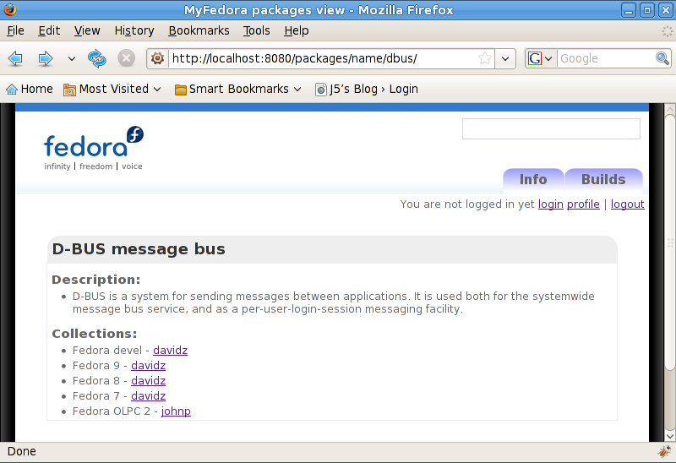Illustration 1: The package info tool
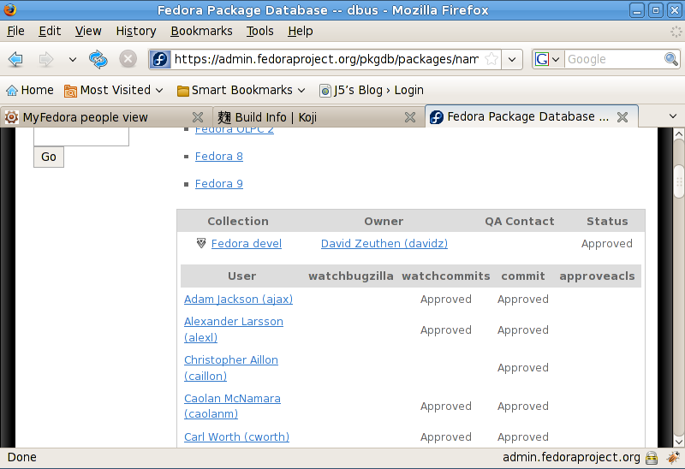Illustration 2: Packagedb showing who is approved for what actions
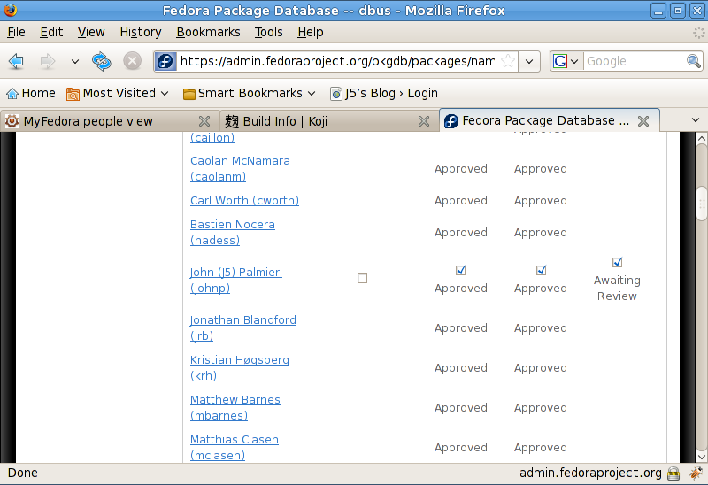Illustration 3: Packagedb showing how I can edit my own permissions
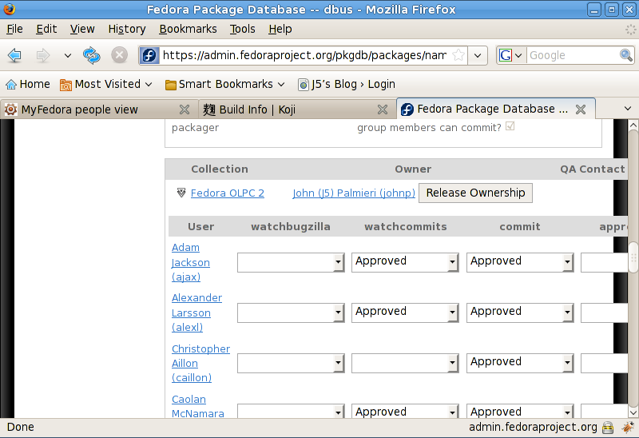Illustration 4: Packagedb showing how I can release my ownership of a package and edit other's permissions when I own the package

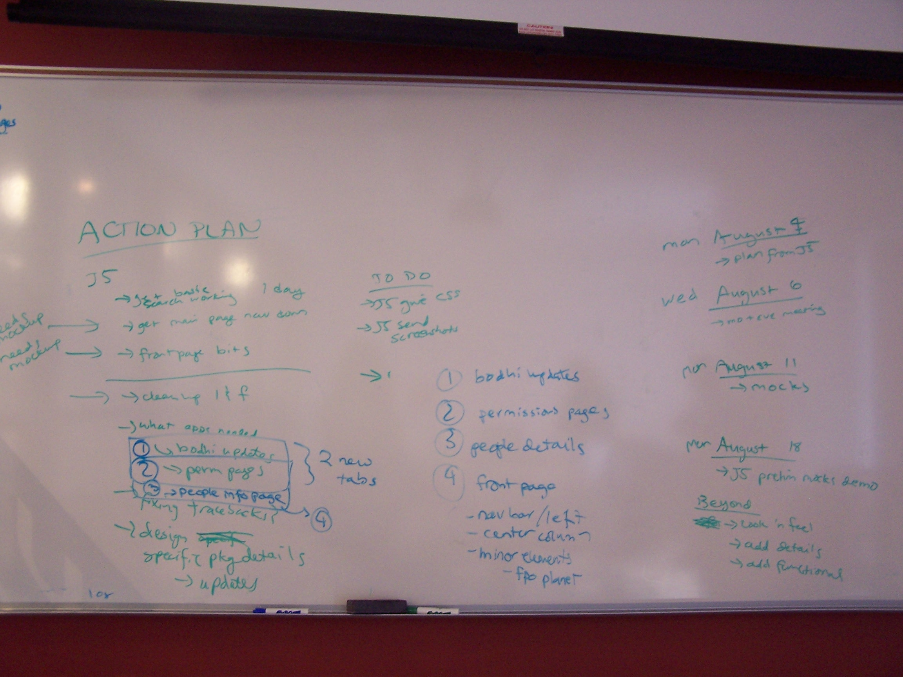Illustration 5: Action plan gathered at meeting

